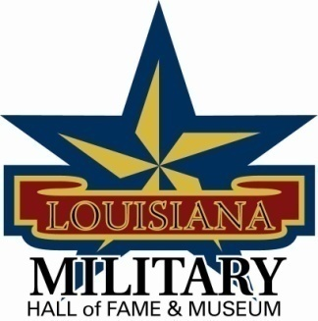

LA Military Hall of Fame & Museum
Chris Crusta Memorial Airport
911 Revis Sirmon Loop
Abbeville, LA 70510
337-898-9645

Governing Board Meeting Minutes – Saturday, February 16, 2013
10:00 am inside the Military Hall of Fame & Museum

Attendees: Guests:
General Robert LeBlanc Crystal Mouton
Al Leger Jesse Weaver
Darrell Minnix Carol Raymond
Joe Hill Alyssa Mouton
Ampy Callatayed
Dewey Coles
Johnny Raymond
Francis Plaisance

The meeting was called to order at 10:30 am and was followed by prayer and Pledge of Allegiance.

Al Leger works for Veterans Affairs and will see what kinds of help he can get for money to purchase paint for the outside tanks.

Crystal Mouton reviewed the new exhibit panel that will be displayed.

Crystal Mouton reviewed the Skeet Shoot to be held on May 25, 2013 at GOL Shooting Range. She asked that everyone help by getting auction items and sell raffle tickets.

Johnny Raymond talked about possibly having a poker run as a fundraiser.

Johnny Raymond will call Mr. Hunt Downer to see if he is still interested in being a part of the board of directors.

General LeBlanc will present the Order of St Maurice to Darrell Minnix at our next Induction Ceremony.

11:30 meeting was adjourned

ral Bob
Leblanc, President
Abbeville

John R. Raymond, Vice President
Breaux Bridge

N.R. Bubba Broussard, Secretary
Abbeville

Joey LeRouge, Treasurer
Lafayette

Secretary Lane Carson
Baton Rouge

Louis Michot
Lafayette

Adrian Bruneau
Jefferson

Joe D. Hill
Lake Charles

Don Sands
Lafayette

Dewey Coles,
Breaux Bridge

Felix Weill
Baton Rouge

Stan Wall
West Monroe

Peyton Cole
Bossier City

